Travelling in India.

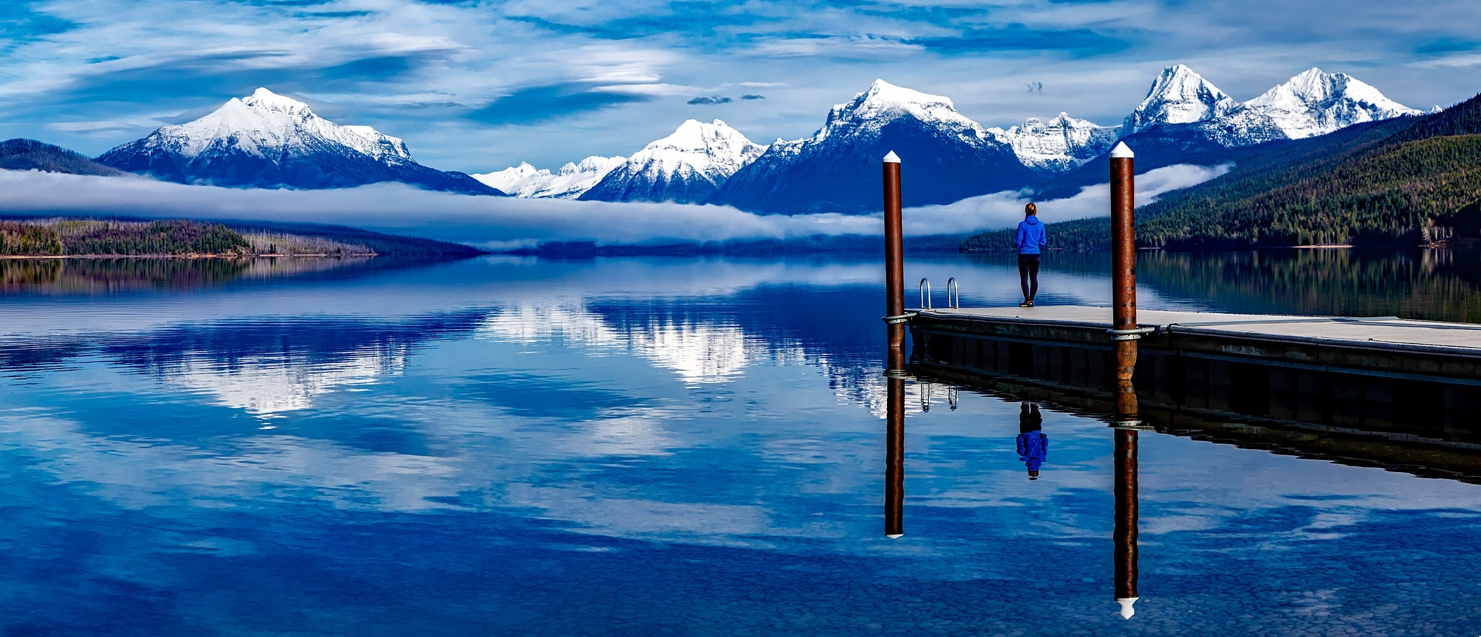

# INDIA is a country where travellers fantasize about – tropical, oriental, ancient India. It is also modern, chaotic India. The wonder that is India never stops overwhelming your senses. It is not a country for the frail and the timid. Unpredictable, spiritual, peaceful, complex, intelligent, emotional – a country that has seen and absorbed many invading and colonising cultures and has grown to a chaotic, vocal, economically booming and fiercely independent democracy that embraces both the poor and the ostentatious luxury people. Commercialisation jostles with creativity and an ancient heritage and teachings already include and accept ultra-modern changes and a fast-paced evolution of ideas and inventions.

# A trip to India is what travel stories are made of. It’s not just the places and the sightseeing that travellers relish, but also the festivals, the arts and craft, the people, the cuisines, and of course, the shopping.

**ECONOMIC TRACES 2018**

According to World Travel & Tourism Council (WTTC) on the economic impact of travel & tourism industry in India, leisure travel spending (inbound and domestic) generated 94.6.

Percent of direct travel & tourism GDP in 2017 compared with 5.4 % for business travel spending. Leisure travel spending is expected to grow by 7.6 percent in 2018, and rise by

# 7.1 percent pa in 2028. Business travel spending is expected to grow by 6.7 percent in 2018, and rise by 7.0 percent pa in 2028.

# According to WTTC, it has said, “2017 was one of the strongest years of GDP growth in a decade with robust consumer spending worldwide. This global growth transferred again into travel and tourism with the sector’s direct growth of 4.6 percent outpacing the global economy for the seventh successive year.”

# The total contribution of Travel & Tourism to GDP was, 9.4% of GDP in 2017, and is forecast to rise by 7.5% in 2018, and to rise by 6.9% pa to, 9.9% of GDP in 2028.